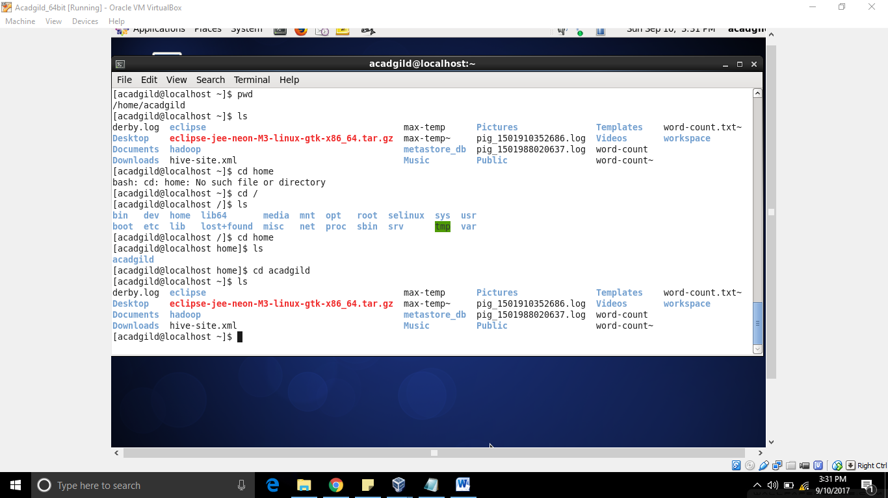

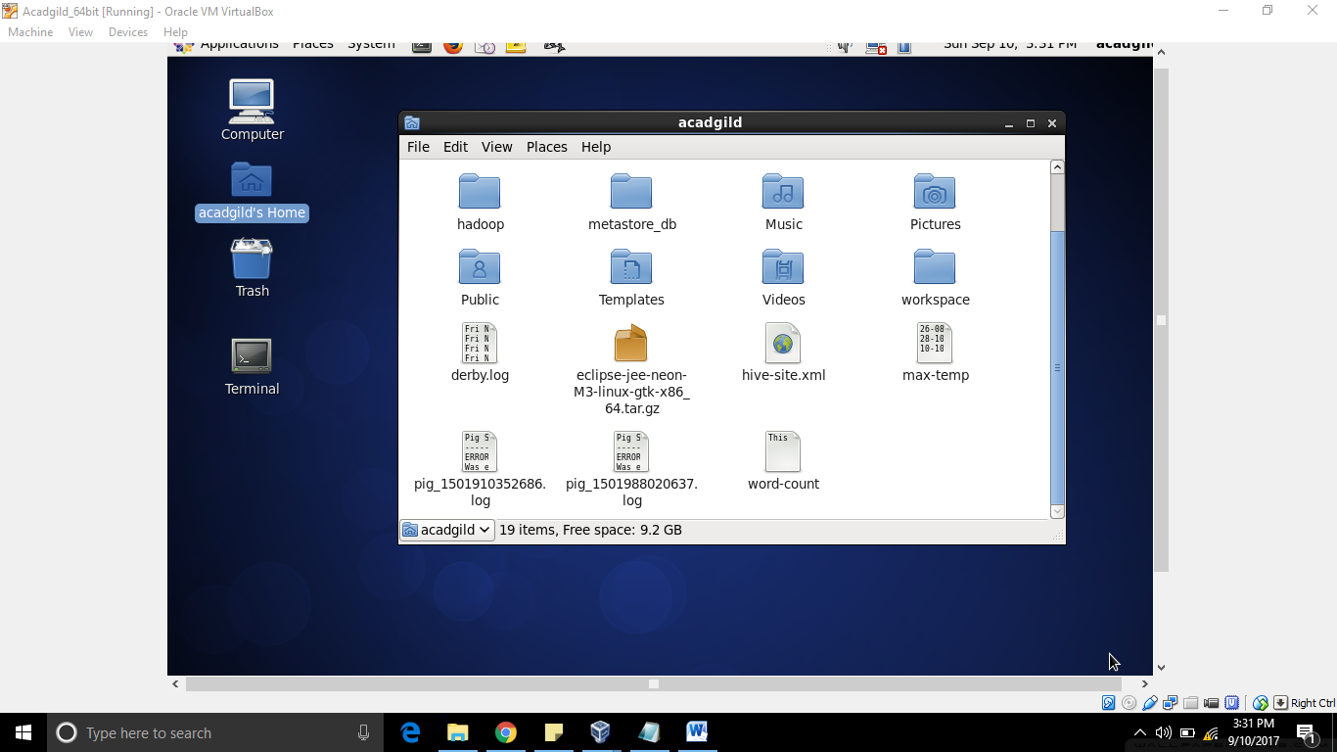

After Moving the file

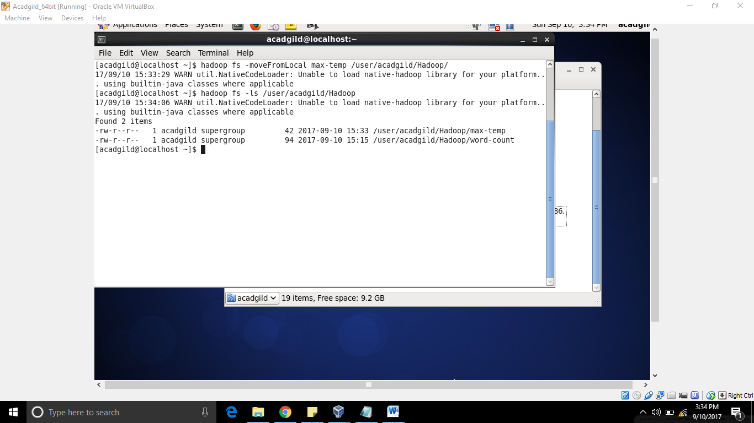

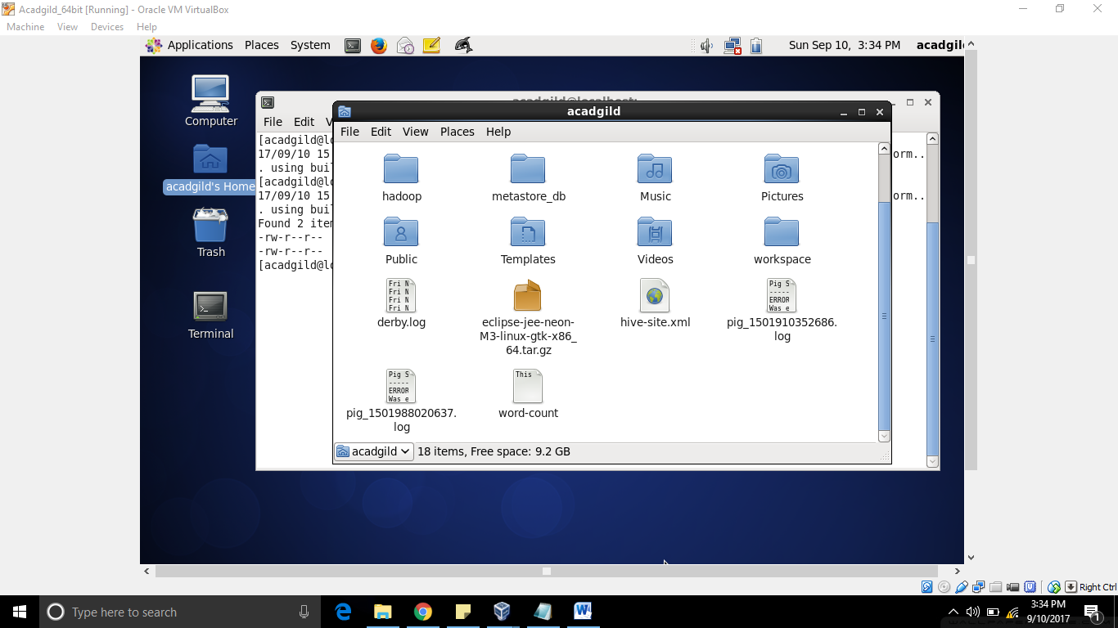

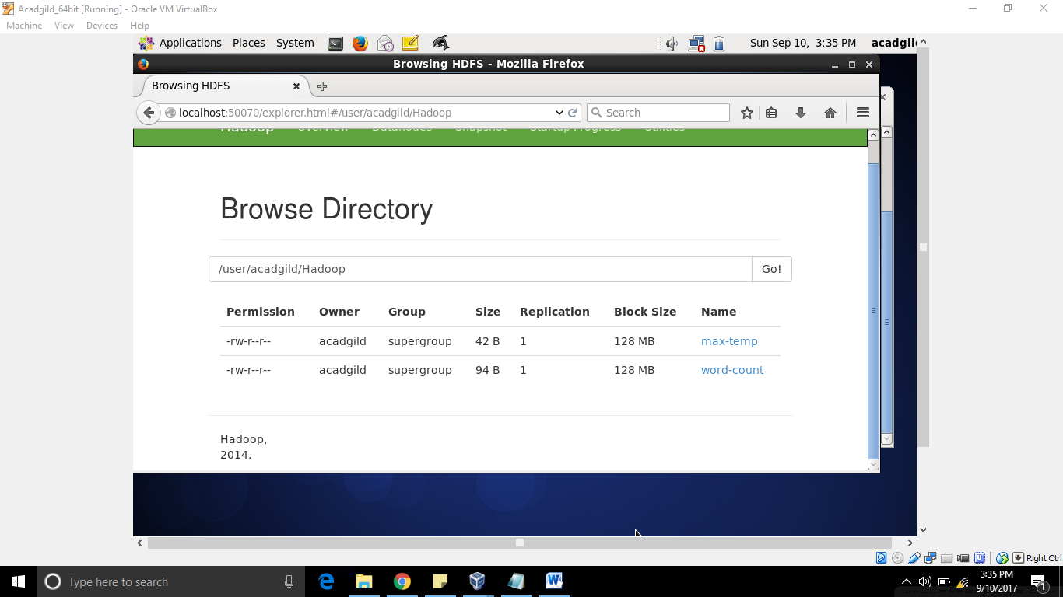

Task -4

Hadoop fs -chmod o-rx /user/acadgild/Hadoop (For Removal)

Hadoop fs -chmod o+rx /user/acadgild/Hadoop (For Removal)

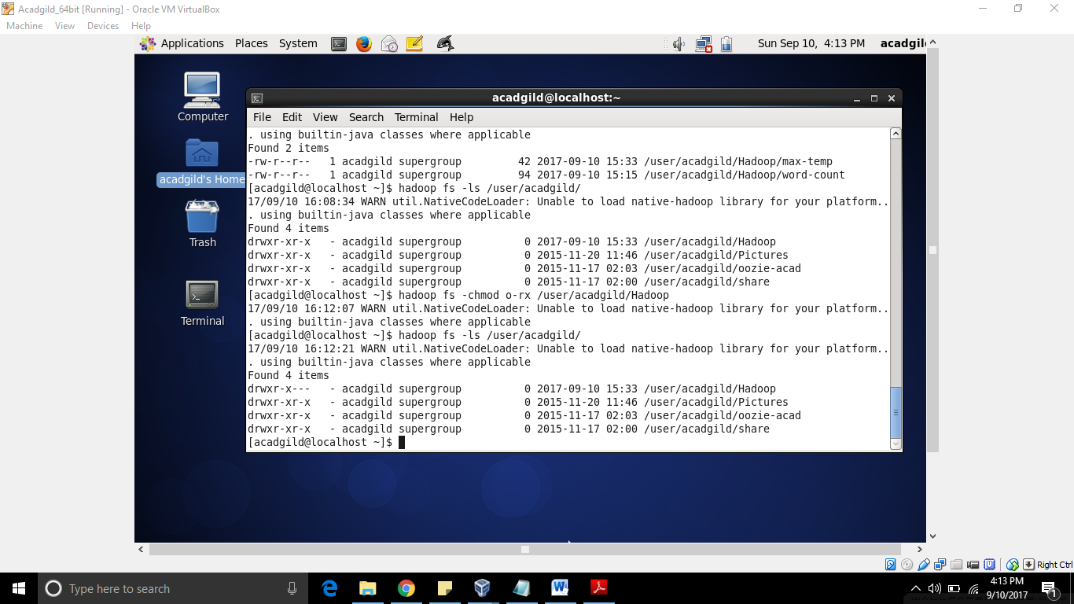

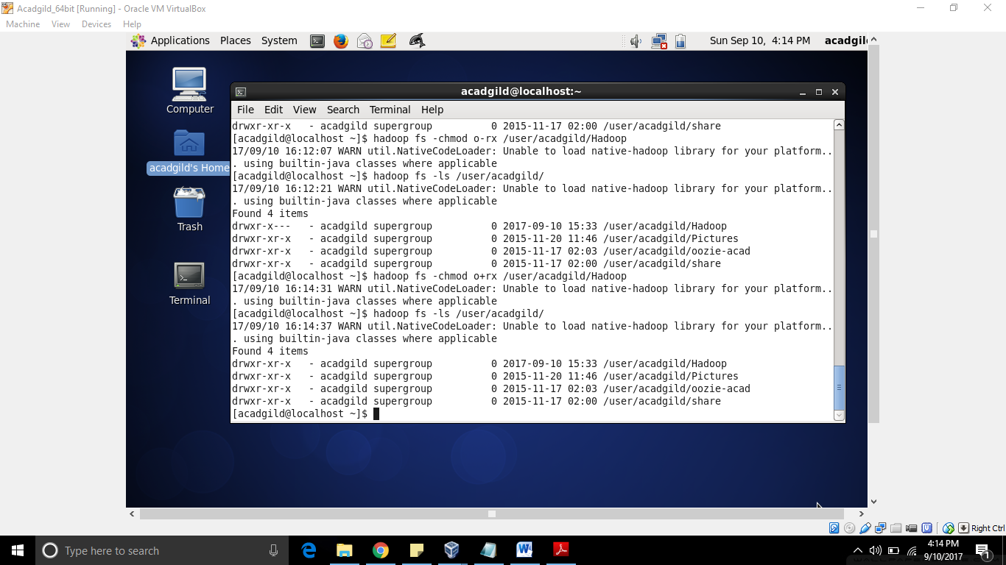

Now we are trying for the file so that others do not have access to max-temp file

Hadoop fs -chmod o-rx /user/acadgild/Hadoop/max-temp

Before Access Change

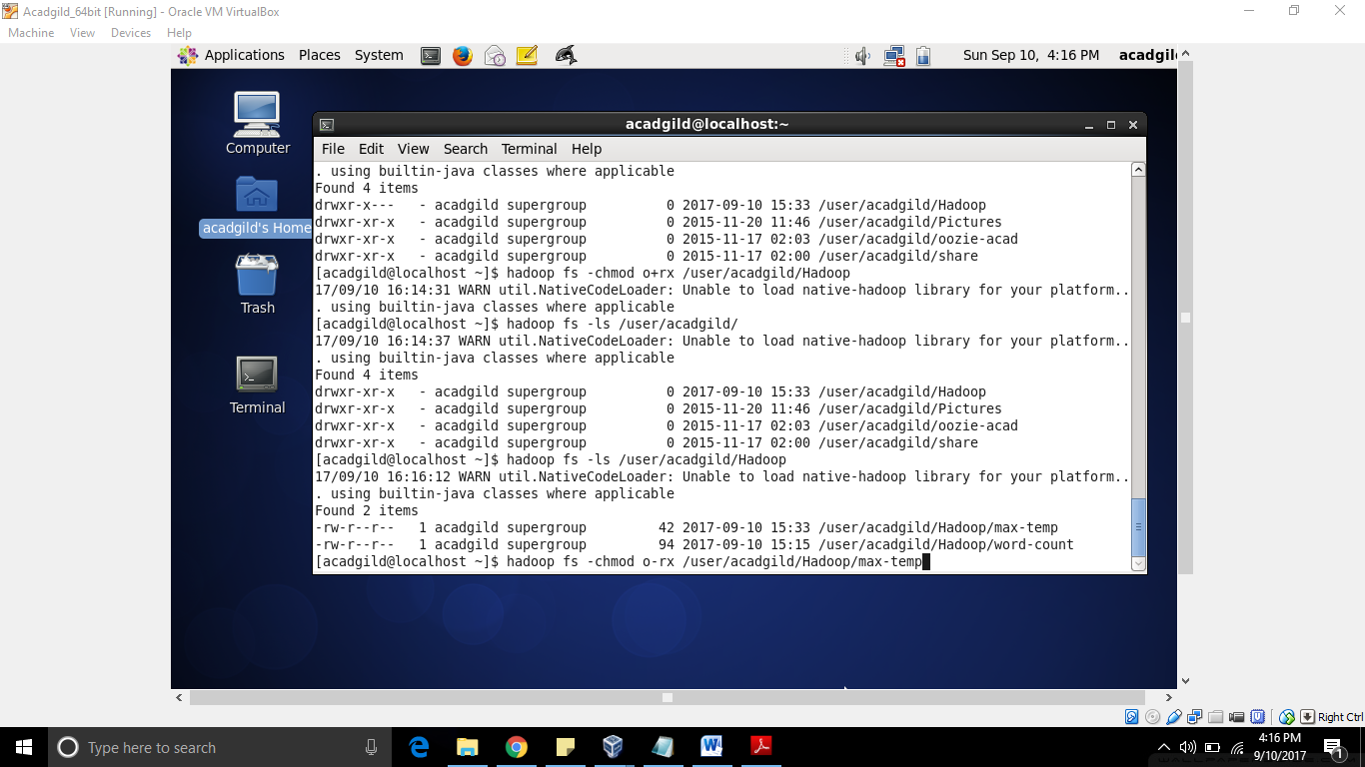

After Access has been changed

